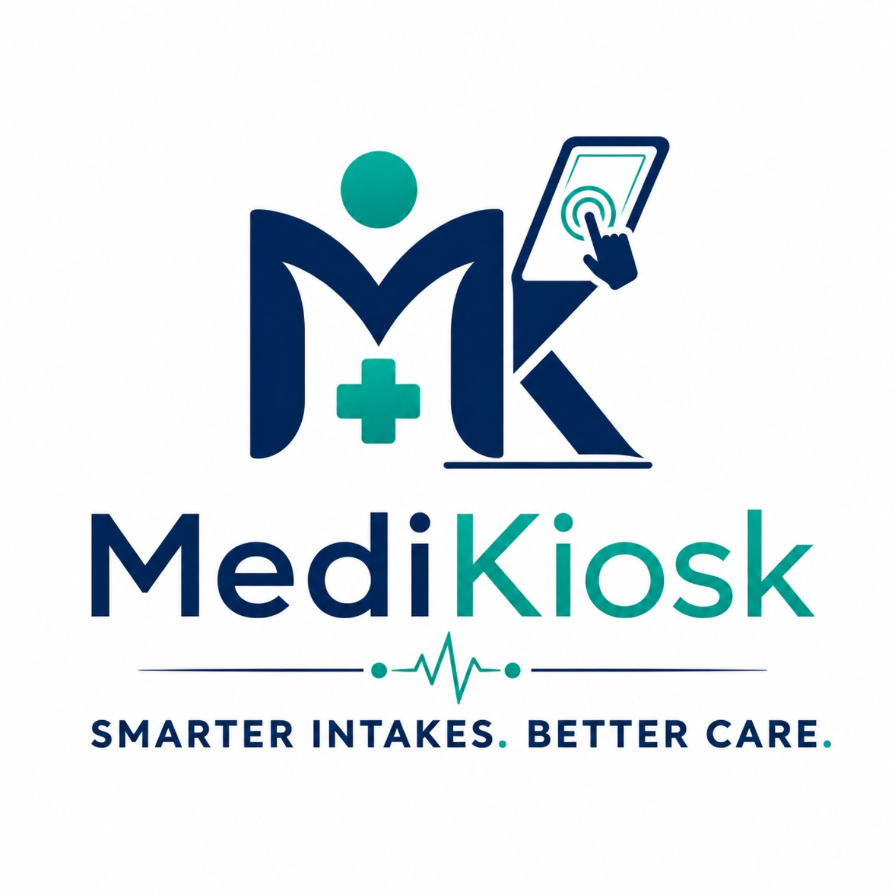

MediKiosk Agent
AI-Powered Clinical History-Taking Kiosk System

Simplifying Patient Care with AI

Project Documentation & Technical Summary
2026 MediKiosk - Smarter Intakes. Better Care.

Table of Contents
1. Project Overview
2. Problem Statement & Motivation
3. System Architecture
4. AI Models Used & How They Work
5. Key Features
6. Technology Stack
7. How the Interview Flow Works (Step-by-Step)
8. Emergency Red-Flag Detection System
9. Multilingual Support
10. Data Flow & Storage
11. API Endpoints
12. Frontend (Kiosk UI)
13. Future Scope
14. Conclusion

1. Project Overview
MediKiosk Agent is an AI-powered clinical history-taking kiosk system designed for deployment in hospitals, clinics, and OPDs (Outpatient Departments). It acts as a smart pre-screening assistant that interviews patients BEFORE they see a doctor, collecting structured clinical history through a natural, conversational interface.
The system supports both text-based and voice-based interviews in 9+ Indian languages, and automatically generates structured clinical summaries that doctors can review instantly on a dashboard. It also includes an emergency red-flag detection system that identifies life-threatening symptoms in real-time.

2. Problem Statement & Motivation
In India's overburdened public healthcare system, OPDs handle hundreds of patients daily. Doctors spend valuable consultation time collecting basic history - name, complaint, duration, medications, allergies - before they can even begin diagnosis.

Key Problems We Solve:
- Long patient wait times due to manual history-taking
- Language barriers - patients speak regional languages, forms are in English
- Incomplete or illegible handwritten case sheets
- Delayed detection of emergency symptoms in crowded waiting areas
- No digital record of pre-consultation data
MediKiosk solves all of these by automating the intake process with AI, making it accessible in the patient's own language, and handing doctors a clean, structured digital summary before the consultation begins.

3. System Architecture
The system follows a layered architecture with four main components:

Architecture Layers:
Layer | Description
Frontend (Kiosk UI) | HTML/CSS/JavaScript single-page app served at /kiosk - the patient-facing touch-screen interface with text & voice modes
Backend API Server | Python FastAPI application (main.py) - handles all REST & WebSocket endpoints, orchestrates AI calls, manages sessions
AI / ML Layer | Groq Cloud (Qwen 27B LLM + Whisper STT) + Google Gemini Live API (real-time voice) + Microsoft Edge Neural TTS (speech synthesis)
Data Layer | SQLite database (medikiosk.db) - stores all completed clinical summaries with structured JSON for the Doctor Dashboard

4. AI Models Used & How They Work
MediKiosk uses three distinct AI models, each playing a specific role in the pipeline. No single model does everything - they are orchestrated together for the best result.

4.1 Qwen 3.8-27B (via Groq Cloud) - The Interview Brain
Provider: Groq Cloud API | Model ID: qwen/qwen3.8-27b
This is the core LLM that powers the intelligent patient interview. It is a 27-billion parameter instruction-tuned model from the Qwen (Alibaba) family, hosted on Groq's ultra-fast inference infrastructure.

How it works:
- The model receives a detailed system prompt that defines its role as a clinical history-taking assistant.
- It is instructed to ask ONE question at a time, in plain language, adapting based on the patient's previous answers.
- It collects 8 required clinical fields: chief complaint, onset, duration, severity, associated symptoms, past medical history, medications, and allergies.
- When all fields are collected, it emits a structured SUMMARY_READY: JSON response.
- If it detects emergency symptoms (chest pain + breathlessness, severe bleeding, stroke signs), it emits a RED_FLAG: alert and stops the interview immediately.
- Temperature is set to 0.3 for consistent, reliable medical responses.
- The model's think tags (internal reasoning) are stripped from the output before showing to patients.
Why Qwen 27B? It offers strong multilingual capability (critical for Indian languages), fast inference via Groq, and high-quality instruction following for structured clinical data extraction.

4.2 Whisper Large V3 (via Groq Cloud) - Speech-to-Text
Provider: Groq Cloud API | Model ID: whisper-large-v3
OpenAI's Whisper Large V3 is used for automatic speech recognition (ASR). It transcribes the patient's spoken audio into text, which is then fed to the Qwen LLM.

How it works:
- The browser records the patient's voice as a WebM audio file using the MediaRecorder API.
- This audio file is sent to the backend endpoint POST /transcribe or POST /interview/voice.
- The backend forwards the audio to Groq's Whisper endpoint for transcription.
- An optional language hint (e.g., 'hi' for Hindi, 'ta' for Tamil) improves accuracy for Indian languages.
- The transcribed text is returned and used as the patient's answer in the interview loop.
Why Whisper V3? It is the state-of-the-art multilingual speech recognition model with excellent accuracy across Indian languages, and Groq provides near-instant inference.

4.3 Google Gemini 3.1 Flash Live - Real-Time Voice Conversation
Provider: Google AI | Model ID: models/gemini-3.1-flash-live-preview
Gemini Live provides a fully real-time, streaming voice-to-voice interview experience. Unlike the Whisper+Qwen pipeline (which is turn-based), Gemini Live enables natural, continuous spoken conversation.

How it works:
- A WebSocket connection is established between the browser and the backend (/ws/interview).
- The patient's microphone streams raw 16-bit PCM audio at 16kHz directly to Gemini Live via the Google GenAI SDK.
- Gemini processes the audio, understands speech, generates a response, and streams back spoken audio (24kHz PCM) - all in real-time.
- The same clinical system prompt is used, so Gemini follows the same interview protocol.
- Audio transcription is enabled for detecting SUMMARY_READY and RED_FLAG events in the text output.
- Voice is set to 'Kore' - a natural, clear AI voice.
Why Gemini Live? It eliminates the separate STT to LLM to TTS pipeline, providing a seamless, low-latency voice experience similar to talking to a real person.

4.4 Microsoft Edge Neural TTS - Text-to-Speech
Library: edge-tts (Python) | Voices: 9 Indian language neural voices
For the turn-based voice mode (Whisper + Qwen pipeline), the AI's text responses need to be spoken aloud. Microsoft Edge Neural TTS provides high-quality, natural-sounding Indian language voices.

Supported voices:
Language | Voice Name
English | en-IN-NeerjaNeural
Hindi | hi-IN-SwaraNeural
Tamil | ta-IN-PallaviNeural
Telugu | te-IN-ShrutiNeural
Marathi | mr-IN-AarohiNeural
Bengali | bn-IN-TanishaaNeural
Gujarati | gu-IN-DhwaniNeural
Kannada | kn-IN-SapnaNeural
Malayalam | ml-IN-SobhanaNeural

5. Key Features
- Adaptive AI Interview: The AI asks one question at a time and adapts follow-up questions based on the patient's answers (e.g., if 'chest pain' is mentioned, it asks about radiation, breathlessness, timing).
- Dual Input Mode: Patients can type answers (Text Mode) or speak them (Voice Mode) - toggle with a single switch.
- 9+ Indian Languages: Full interview support in English, Hindi, Tamil, Telugu, Kannada, Malayalam, Marathi, Bengali, and Gujarati.
- Emergency Red-Flag Detection: Automatic detection of life-threatening symptoms (cardiac events, stroke, severe bleeding, fainting) with instant alerts.
- Structured Clinical Summaries: Auto-generated summaries with chief complaint, onset, duration, severity, associated symptoms, past history, medications, and allergies.
- Doctor Dashboard API: REST API endpoints to retrieve all patient summaries - ready for integration with hospital EMR systems.
- Real-Time Voice (Gemini Live): Fully streaming voice-to-voice conversation for a natural interview experience.
- Patient Consent Flow: GDPR-style consent screen before data collection begins.
- SQLite Persistence: All summaries are stored in a local SQLite database for offline reliability.

6. Technology Stack
Category | Technology | Purpose
Backend Framework | FastAPI (Python) | REST API + WebSocket server
LLM (Interview Brain) | Qwen 3.8-27B via Groq | Adaptive clinical questioning
Speech-to-Text | Whisper Large V3 via Groq | Voice transcription (9+ languages)
Real-Time Voice AI | Gemini 3.1 Flash Live | Streaming voice-to-voice interview
Text-to-Speech | Microsoft Edge Neural TTS | AI speaks in Indian languages
Frontend | HTML + CSS + JavaScript | Patient-facing kiosk UI
Database | SQLite | Clinical summary storage
Server | Uvicorn (ASGI) | Production-grade async server
API Documentation | Swagger UI (FastAPI auto-gen) | Interactive API docs at /docs
Environment | python-dotenv | Secure API key management

7. How the Interview Flow Works (Step-by-Step)
- Step 1 - Welcome & Consent: Patient sees the MediKiosk branded welcome screen with feature highlights. They must tick the consent checkbox agreeing that their data will be used for medical purposes before proceeding.
- Step 2 - Patient Name Entry: The patient enters their name. This is attached to their clinical summary for doctor reference.
- Step 3 - Language Selection: The AI's FIRST question asks the patient which language they prefer. Once selected, the entire interview continues in that language.
- Step 4 - Adaptive Interview: The AI asks one question at a time, adapting based on answers. For example: Patient says 'headache' then AI asks about location, type of pain, triggers. Patient says 'chest pain' then AI immediately checks for radiation, breathlessness (red-flag screening).
- Step 5 - Data Collection: The AI systematically collects: chief complaint, onset, duration, severity, associated symptoms, past medical history, current medications, and known allergies.
- Step 6 - Summary Generation: Once all 8 fields are collected, the LLM emits a SUMMARY_READY: response with structured JSON. The backend parses this, generates a formatted clinical note, and stores it in the SQLite database.
- Step 7 - Doctor Dashboard: The summary is now available via REST API (GET /summaries, GET /summary/{id}) for the doctor to review before the consultation.

8. Emergency Red-Flag Detection System
One of MediKiosk's most critical safety features is its real-time emergency detection. The AI is trained (via system prompt) to recognize combinations of symptoms that indicate life-threatening conditions.

Red-Flag Triggers:
- Chest pain + breathlessness or arm radiation - Possible cardiac event
- Severe bleeding + dizziness or fainting - Hemorrhagic emergency
- Sudden weakness/numbness + speech difficulty - Possible stroke
- Loss of consciousness or syncope - Neurological emergency
When triggered, the AI immediately responds with RED_FLAG: <reason> and the interview stops. The frontend displays a prominent red alert card telling the patient to alert clinical staff immediately. In voice mode, the AI speaks: 'Attention. This symptom may require immediate medical attention. Clinical staff is being alerted.'

9. Multilingual Support
MediKiosk is designed for India's linguistically diverse population. The system handles multilingual operation at every layer:
Component | Multilingual Capability
LLM (Qwen 27B) | Conducts full interview in patient's chosen language. Summary JSON is always in English for doctor consistency.
Whisper V3 | Transcribes speech in all 9 supported Indian languages with language-hint optimization.
Edge Neural TTS | Speaks AI responses using dedicated Indian neural voices (see voice table in Section 4.4).

10. Data Flow & Storage

Text Mode Data Flow:
Patient types answer -> POST /interview -> Qwen 27B processes -> AI reply returned -> displayed in chat

Voice Mode Data Flow (Turn-based):
Patient speaks -> Browser records WebM audio -> POST /interview/voice -> Whisper transcribes -> Qwen 27B processes -> Edge TTS speaks reply -> Audio + text returned

Voice Mode Data Flow (Real-time / Gemini Live):
Patient speaks -> Browser streams 16kHz PCM via WebSocket -> Gemini Live processes -> 24kHz PCM audio streamed back -> Patient hears AI in real-time

Database Schema (SQLite):
Column | Type | Description
id | INTEGER PK | Auto-incremented summary ID
patient_name | TEXT | Patient's name
summary_json | TEXT (JSON) | Structured clinical data as JSON string
summary_text | TEXT | Formatted clinical note for display
red_flag | TEXT (nullable) | Red-flag reason, if triggered
source | TEXT | 'text' or 'voice' - interview mode used
created_at | TEXT (ISO) | UTC timestamp of summary creation

11. API Endpoints
Method & Path | Input | Purpose
GET / | - | Health check
GET /kiosk | - | Serve the patient-facing kiosk UI
POST /interview | JSON (history + answer) | Text-based interview turn
POST /interview/voice | Multipart (audio + history) | Voice interview: transcribe + process + TTS reply
POST /transcribe | Multipart (audio file) | Standalone speech-to-text transcription
POST /generate-summary | JSON (conversation history) | Force-generate a summary from any conversation
GET /summary/{id} | Path parameter | Retrieve a single saved clinical summary
GET /summaries | - | List all saved summaries (Doctor Dashboard)
GET/POST /tts | Text + language | Direct text-to-speech synthesis (returns audio/mpeg)

12. Frontend (Kiosk UI)
The frontend is a single-file HTML application (live_demo.html) designed for deployment on touchscreen kiosk devices. It features a premium, dark-themed UI built with glassmorphism design principles.

UI Screens:
- Welcome Screen - Branded landing page with feature icons, consent checkbox, and 'Get Started' button.
- Patient Name Entry - Simple input field to capture the patient's name.
- Chat Interface - Conversational chat UI with AI messages (left-aligned, dark) and patient messages (right-aligned, gradient purple).
- Text/Voice Toggle - A smooth toggle switch to switch between typing and voice input modes.
- Voice Mic Button - Large circular microphone button with pulse animation when recording.
- Summary Card - Green-bordered card displaying the formatted clinical summary after interview completion.
- Red-Flag Alert Card - Red-bordered emergency card with urgent messaging.

Design Details:
- Font: Inter (Google Fonts)
- Color scheme: Deep navy (#0f172a) background with indigo (#6366f1) accents
- Animations: fadeIn, slideIn, logoFloat, typing indicator bounce, mic-pulse
- Full F11 fullscreen support for kiosk deployment

13. Future Scope
- Lab Report OCR: Upload and parse lab reports (blood tests, X-rays) using OCR/Vision AI.
- Doctor Dashboard Web App: Full React/Next.js dashboard for doctors to review, annotate, and manage patient summaries.
- EMR Integration: Connect to hospital Electronic Medical Record systems (HL7/FHIR standards).
- Patient Authentication: Aadhaar-based or OTP-based patient identity verification.
- Offline Mode: Edge deployment with on-device models for areas with poor connectivity.
- Vitals Integration: Connect with IoT devices (BP monitor, thermometer, pulse oximeter) to auto-populate vitals.
- Analytics Dashboard: Track interview completion rates, common complaints, red-flag frequency by region.

14. Conclusion
MediKiosk Agent demonstrates how modern AI technologies - large language models, speech recognition, neural text-to-speech, and real-time voice APIs - can be combined into a practical healthcare solution that addresses real-world problems in Indian hospitals.
By automating the patient history-taking process, MediKiosk reduces doctor workload, eliminates language barriers, catches emergencies early, and creates structured digital records - all through a simple, accessible kiosk interface that any patient can use.
The system is designed to be modular, extensible, and ready for real-world pilot deployment in hospital OPDs, community health centers, and telemedicine setups.

- End of Document -

